**Natural Resources and Macroeconomy**

**Energy and Environmental Economics**

**Assignment 3**

**Mert Ekici - 26772**

**ekicimert@sabanciuniv.edu**

**Abstract**

Aim of this paper is to answer the given questions that investigates the relation of natural resources and macroeconomics. Questions are based on three major articles as sources, needs to be answered by analyzing empirical evidences which were used in these articles, and duplicating some of the models for better understanding of the mechanisms behind the theories.

**A - Oil and the Macroeconomy since the 1970s (Barsky and Kilian, 2004)**

**Question 1**

For a long time, economists have been temptated by emprical evidences that points oil price shocks and its relation to macroeconomic factors. Since 1970s, many oil price shocks have been observed and these sharp changes were accused with causing recessions, inflation, reducing productivity and lowering economic growth. This paper reviews these arguments, tries to provide empirical evidences that support previously stated relations. By using various data beginning from 1970s, macroeconomic fluctutations will be traced on how oil related factors might have been affected them. The aim is to challenge common view that supports the role of political events in shaping the oil market which infers causality from oil prices to macroecenomic variables.

Empirical data provided in paper:

* Table 1: The Coincidence of Oil Date and Recessions after 1972
* Table 2: Growth in Total Factor Productivity and the Real Price of Oil Imports
* Figure 1: Real Price of US Crude Oil Imports and Recessions
* Figure 2: Monthly CPI Inflation Rates and Oil Dates
* Figure 3: Oil Price Uncertainty and Real Consumption of Durables
* Figure 4: Oil Price Uncertainty and Real Investment
* Figure 5: Percentage change in the Nominal Price of Crude Oil Imports
* Figure 6: CPI Inflation in the GDP Deflator, Detrendend Log Real GDP and the Unemployment Rate in Excess of 5.5 Percent

By listing the empirical observations above, the conclusion derived is that the authors used the different types of data that show the change in macroeconomic factors and oil related conditions. In Table 1, Recessions are matched with the oil-related incidents to decide whether they are coincidences or not. Table 2, Figure 2 and Figure 6 examine the macroeconomic terms such as total factor productivity, inflation rates and GDP deflator by tracing the variations in oil prices and oil shock dates. As a whole, selection of the data is well directed to make an empirical analysis about the topic since the economists worked on this paper eventually concluded on the weakness of common view and the insufficieny of proofs. Throughout the article, links between political conditions (wars, embargoes etc.) and oil relevant fluctations are pursued on empirical evidences, tried to be associated with macroeconomical balance of U.S. with the support of economic theories. Infering causality demands scientific methodology to test hypotheses with statistical methods and even then the unbiasedness of the data and exogeneity of the model are not guarenteed. In the frame of this professional work and elaborative analysis, we can consider those observations are not empirically sufficient to be considered as evidence for the causal effect of oil shock on macroeconomy. The results points two major findings;

* the effect of political events in the Middle East differs greatly from case to case (observations are not consistent),
* contrary to popular belief, the oil market disturbances are less effective due to the insufficient empirical support (p. 19).

Thus, we can not consider those empirical observations as an evidence for causality of oil market on macroeconomy.

**Question 2**

To understand the potential mechanisms that might explain the relationship between oil shocks and macroeconomy, the causal relation between oil prices and recessions, inflation, economic growth is investigated sepearately as sub-secitons in the paper.

**Oil Price Shocks - Recessions**

$$Y=Q[K,L,O]$$

Holding L and K constant, oil-based fluctations (Q as imported oil quantity) must affect macroeconomics in small amounts. The share of oil in output is estimated to be no larger than 4 percent (p. 5). In this case, 10 percent increase in oil prices causes less then 0.5 percent reduction in output. Since the changes in oil quantity do not shift the demand curve for labor and capital services, there is no direct effect of oil price shock under perfect competition (p. 5). Other assumption is the expected decrease in the demand for capital services due to rise in energy prices but expected depreciaton of capital as lower prices for equipments was not supported empirically. In terms of wealth transfer form industrial countries to oil-producer countries (due to oil trade), observed wealth change tends to be small which is generally caused by lower propensity to purchase industrialized countries’ output. One of the obvious reactions to be expected is the depress of energy-using goods’ purchases. However, there is no increase in unemployment in 1986 (collapse of OPEC prices) which should have been increased by the reallocation of labor across sectors due to the shift in demand (p. 7). When car sales (oil using durable) is followed, there is no evidence of sharp drops in spendings (p. 8). The only detected reactions are the fall in investment that caused by uncertainty and Federal Reserve’s policy against inflation triggered by the price shock. In many macroeconomic sides, the idea of “oil price shocks create recessions” is weak (p. 9).

**Oil Price Shocks – Inflation**

Theories on explaining how oil causes a recession is not explanatory to relate stagflation. Thus, it is crucial to determine the role of oil in explainin inflation. Rotemberg and Woodword (1996), validates the unambigious effect of oil shocks that behaves inflationary for the prices of the output (p. 10). The reason is based on the decline in industrial production which oil price shocks create. The same model also underlines that there is no theoretical base that the GDP deflator would increase as a response to the sudden increases of oil price (p. 10). This deduction is important because it reveals the difference between CPI inflation and the inflation rate of GDP deflator after an oil price shock. Nevertheless, there is no powerful evidence that oil price shocks end up with higher inflation rates but strong evidences point to the sharp changes in CPI inflation rate after significant oil price changes.

**Oil Price Shocks – Economic Growth**

As findings about oil price shocks and their impacts on macroeconomic concepts above suggest, these oil price changes might also produce long-term outcomes for economic growth. As I mentioned at the beginning of this report, the rise in the oil prices in 1974 has been accused for the slowdown of the productivity which started at the first quarter of 1973. Olson (1988) states that “the evidence has not been kind” to picture the failed oil-based explanations of the productivity slowdown (p. 11). The major problem here is the small share of energy cost in GDP which is unable to explain productivity slowdown. One possibility to clear this mistaken view is that energy-inefficient capital became obsolete by high oil prices which looked like a decline in productivity. The opportunity for substitution to oil alternatives were exteremely limited during 1973 oil price shock. Inevitable productivity loss might rised from this obligation. Although there are number of additional views on the oil price shocks’ causality on economic growth, there is no solid empirical evidence that can establish a link from oil prices to productivity (p. 11).

**Question 3**

Collective knowledge states that the major price increases of oil tend to be a consequence of political events in the Middle East. The counterexample of this statement is the increases in oil prices between March 1999 and November 2000 which was definitely a major one but in this period there were no extra conflicts in the Middle East. Even in the absence of political shocks and wars, 1999-2000 oil price increses might be formulated by the OPEC oil cartel (p. 11). As seen from this example, reasons for the oil price shocks must be divided into the sub-sections and analyzed separately to interpret better.

**The Role of Cartels**

Obviously the world level demand for oil is critical for understaning and estimating oil prices but OPEC has an important role in the prices as well. Oil Cartels are able to keep prices high when producers are unable to give away other cartel members that exceed the production quota. In the times of low demand if prices fall to a critical point, the cartel members might choose to supply the market with their excess output. Other reason for the cartel’s role is the OPEC’s tendency to preserve stability. A pending recession may damage the interests of OPEC. After the first signs of possible U.S. recessions, oil price began to slip. Exchange rates can also be a determinant for pricing policies of OPEC. For example in a case where dollar depreciates, OPEC justifies the higher prices (similar to 1970s case). Additionally, weaker dollar might stimulate demand and possible reaction from the cartel boosts the oil prices. By looking all the motives indicated, the role of cartels on the oil prices is undeniable.

**The Role of Major Political Events in the Middle East**

The common belief suggests that sudden changes in the price of oil possibly caused by upredictable political events in the Middle East that shifts supply curve of oil (p. 13). Frequently encountered examples of this events are military events like outbreak of wars. On the contrary, not all oil shocks follow similar patterns when empirical observations are interpreted. For example, after October war of 1973 and the collapse of OPEC in 1985, the invasion of Kuwait in 1990 are associated with sharp oil price spikes, whereas the Iranian revolution and 1999 OPEC meeting were followed by relatively small but persistent positive changes in oil prices. The result can be drawn here is that, the political events in the Middle East are effective on crude oil prices but the magnitude and the change patterns varies largely.

**The Role of Wars**

It might seem natural to observe changes in oil prices because of the wars in the Middle East but it is far from obvious (p. 14). The simple mechanism here is when there is an interruption to the production and shipments of crude oil of the Middle East, these obstacles cause the decrease in the supply which is going to be reflected as oil price shocks in a short time. Other view supports the idea of increase in oil demand due to precautionary attempts to stockpile oil when the feel of war likelihood urges. There are inconsistencies where Iran-Iraq war’s effect and the effect of Kuwait’s invasion do not match. Other than variations of the consequences, some major price increases are also too late-coming that the link between war and oil shock can be questioned. Most of the 1979 increase appeared almost more than half a year after the Iran revolution. Oil supply is not only related to warring parties that produce oil but also depends on the response of countries like Saudi Arabia. As a whole, all observed oil price shocks might be attributed to uncertainty rather than just wars.

**The Role of Embargoes**

The 1973 shock was similar to 1990’s in magnitude and at first sight this was explained war based but the delay created question marks. Thus, there is no direct relation to the October 1973 war. Most of the countries that involved war (Egypy, Jordan, Syria, Iraq) were not even significant oil producers at that time. The dots can be connected by looking the oil embargo imposed by OPEC Arab countries in late 1973 (p. 16). To what extend, political decisions did play role in the action of embargo? At the time, there was no visible intersection of economic and political objectives. Objective of high oil prices had been achieved in early 1974 and the political aims of the embargo and embargo itself were quietly ignored. Potential reasons for the embargo was the fears about future oil supplies but the macroeconomic background also need to be examined as a greater medium that all the interactions happen in it.

**The Role of Global Macroeconomic Conditions**

As pointed out before, neither cartel actions, nor embargoes nor the political unstability on the price of oil are independent from global macroeconomy. Besides the institutional effects, global macroeconomic conditions also affect the oil prices directly by shifting the demand curve (p. 16). Interestingly, many economists do not accept the oil prices responds to macroeconomic forces as other industrial commodities do. The upward movement of the oil prices in the early 1970s was not caused by the fall of productivity, but the “worldwide monetary expansions” that pull output levels above their potential which led to low interest rates (p. 17). These economic fluctuations result in the recessions that followed by the increase in real interest rates and start of the oil price fallings which eventually collapsed at 1986, although OPEC cartel has tried to sustaing higher price levels with full efforts. The view states that high world economic activity and strong demand for oil trigger the expansion of capacity that might end up with the price collapse (p. 17). Therefore, the role of global macroeconomical conditions must be included such studies that investigate the causality of oil price shocks powered with broad emprical observations.

**B - Natural Resource Abundance and Economic Growth (Sachs and Warner, 1995)**

**Question 4**

It is frequently observed that countires with natural resource wealth have failed to grow faster than the countries wihtout rich resources. This phenomenon is called “Natural Resource Curse”. In “The natural resource curse: a survey”, Jeffrey A. Frankel tests this theory by using wide sample of countries that fits the initial conditions. This paper approaches the phenomenon by considering six different channels where natural resources affect the economic performance negatively.

**Long-term Trends in World Commodity Prices**

Declining trend in commodity prices was hypothesized by Paul Prebisch and Hans Singer in the 1950s and the reasoning behind was the inelasticity of world demand for primary products with respect to world income (p. 6). If this hypothesis is true, then specializing in rich natural resources for developing countries would be a “bad idea”. On the contrary, there are other arguments that indicate the upward trends in the long run. The explanation of these arguments is the non-renewable being of the oil and minerals. Since the supply is fixed, long-term trend will gradually move upward (except agricultural products or renewable sources). In brief, although there are many theories on long-term tendency, empirical findings point that there is no consistent trend (p. 35). Still other five channels have some truth on the explaining the curse.

**Meditum-term Volatility of Commodity Prices**

As we discussed at the first three questions, the price of oil follows an unpredictable path, sometimes called price shocks (whether upward or downward). Generally, price of oil and natural gas tends to be more volatile than minerals and agricultural commodities (p. 11). The volatility of the prices (natural resource) is believed to be bad for economic growth. Some studies and examples from historical events suggest that high votality might assist the rapid growth of economies. However considering the risks of volatility, diversification of the sectors make the countries better of comparing the specialized countries. Thus, the highness of the price votality imposes the risks for economic performance.

**Commodity Specialization and Growth**

Seeking the possible negative relation of specialization in natural resources and growth is one of the key methods of understanding the natural resource curse. Diversification is usually considered desirable by many countries. Ignoring some several false arguments and classical economic theory’s “countries must produce by using their comparative adventage” statement, Brazil’s attempts to industrialize and pay-offs show that policy-induced diversification can be helpful for economic development (p. 15). Hence, natural resource specialization can be harmful to growth if it pushes out the other sectors (mostly manufacturing) that contribute the economy.

**Mineral Riches and War**

Inner conflicts definitely are detrimental to economic development, especially when they are violent or country-wide. If there are valuable sources such as diamonds or other luxurious commodities instead of doing it by the rule, factions tend to fight for it. As the paper lists, many previous works find that the economic dependence on natural resource wealth is correlated with civil wars (p. 16). Since the conflict increase by dependence increases, we can conclude that mineral riches can lead wars and this is an obvious inhibitor to development.

**Institutions**

The quality of institutions is prominently related with the good performance of the economic development. Weak institutional structure leads inequality, dictatorship and corruption. These consequences will eventually become obstacles to development. But how the natural resource curse weakens the institutions? Studies shows that the commodities called as “point source commodities” (oil, minerals, plantation crops, coffee and cocoa) might lead to poor institutions where unbalanced class structure, inequality and corruption with totalitarian regime can occur. In addition to weak institutions, natural resource wealth can also restrain the functionality and the development of democracy, although there is no observed direct relation that democracy leads to economic growth.

**The Dutch Disease**

Disproportionate growth and development of one specific sector of the economy (natural resources) comparing with the other sectors and the negative effects of this concept is called “Dutch Disease”. This paradox is caused by the improvement of one sector which creates negative impatc on overall economy. Resulting from a commodity spike, the Dutch Disease conduces to an appreaciation of the currency, increase in government spendings. They both together, boost nontraded goods and services such as housing and render uncompetitive noncommodity export sectors such as manufactures. (p. 35). After that, if the world commodity prices turn back to normal levels, restoring the economy is too difficult because of the accumulated debts, government spendings and due to the shrinkage of manufacturing sector. Following the causative mechanism here, uncovers the Dutch Disease as our final channel that leads to the Natural Resource Curse.

**Question 5**

To duplicate Table 1 by using curse.dta, we need to estimate multiple linear regression model with variables gea7090 as a dependent variable, and sxp, sopen, linv7089, rl, dtt7090 as explanatory variables. Let’s know these variables;

* gea7090: Average annual growth in real GDP / economically-active population (between 1970 – 1990)
* lgdpea70: Natural log of real GDP / economically-active population in 1970.
* sxp: 1970’s share of exports’ primary products in GNP
* sopen: Fraction of years which country is rated as an open economy
* linv7089: natural log of the ratio of real GDI to real GDP (1970 – 1989 average)
* rl: Rule of law index
* dtt7090: Average annual growth in the log of the external terms of trade (1970 – 1990).

In brief, the variable SXP is the measure of primary source intensity. Other variables will be added gradually (excluding outlier countries and Chad, Gabon, Guyana, Malaysia) to show reversed relation between natural source intensity and economic growth.

**controlling: lgdpea70**

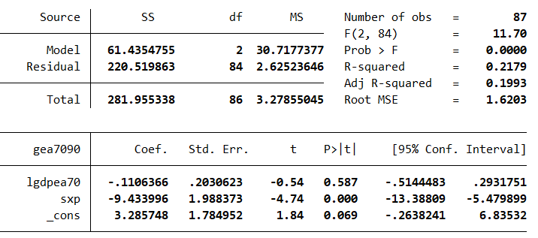

**controlling: lgdpea70, sopen**

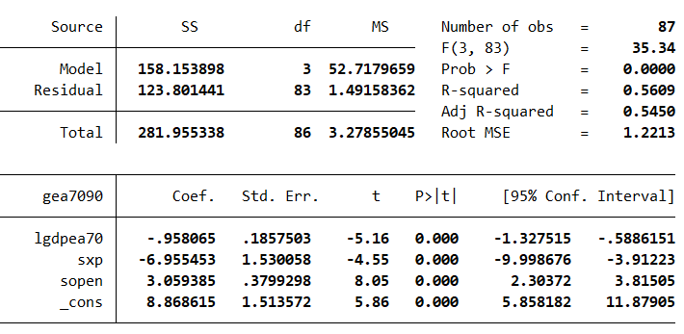

**controlling: lgdpea70, sopen, linv7089**

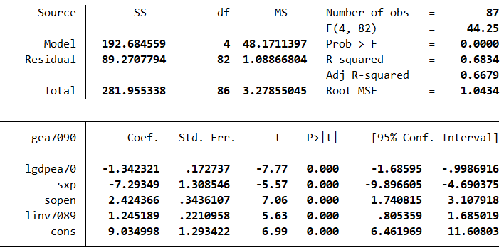

**controlling: lgdpea70, sopen, linv7089, rl**

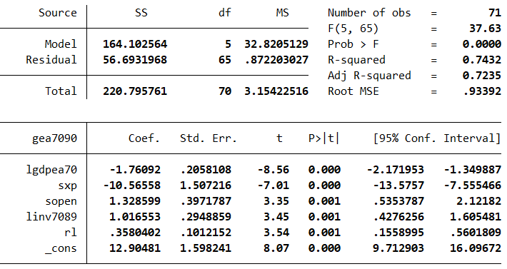

**controlling: lgdpea70, sopen, linv7089, rl, dtt7090**

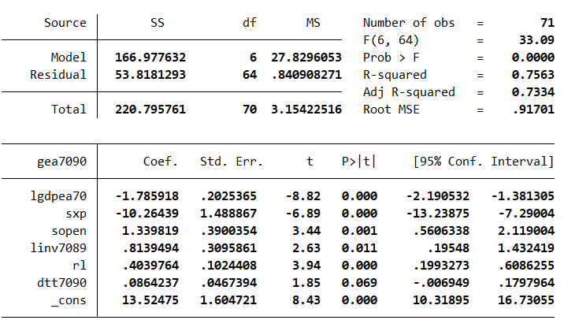

In first regression model, we regressed the GDP growth on the log of initial GDP and the share of primary exports of 1970’s GDP. As can be seen from the model, higher rate of sxp (share of primary exports) is linked with lower growth for 20 years period (estimated coefficient of sxp is -9.43). One percentage point increase of the share of primary exports decreases annual GDP growth by 9.43 percentage points and intial GDP has negative effect on the growth. Although this simpler version of the model supports the existence of natural resource curse, we need to control some other factors that might affect growth and cause endogeneity problem. Here are the variables and what we try to control by using them;

* lgdpea70 🡪 size of the economy by initial gdp over active population
* sopen 🡪 outward orientation by the openness of the economy
* linv7089 🡪 capital accumulation by investment to GDP ratio (1970-1989)
* rl 🡪 institutional quality by rule of law variable
* dtt7090 🡪 commodity price shocks by export import price ratio (1970 – 1990)

Remaining estimated regression models of Table 1 show that the effect of resource intensity on growth remains significant after controlling all these variables. When we looked to coefficients of sxp, they appear as (in order) -9.43, -6.96, -7.29, -10.57, -10.26. It is possible that something else might also affect the growth. To prevent and isolate the external effects, we control variables that measures some of the ideas which try to explain the growth change with factors other than natural resource abundance. For example, in the second regression we add a variable called “sopen” for considering outward orientation of the country. Other concepts that tried to be controlled in this model are capital accumulation, institutional quality and global commodity price shocks via linv7089, rl (rule of law variable from Keefer and Knack) and dtt7090. The evidences suggest that adverse effect of natural resource wealth on economy is not simply a reflection for institution quality or low investment rates. SXP remains forceful after controlling such long-run effecs in external terms. Controlling the external variables and excluding outliers gets us a model with high explanatory power which clearly supports the “Natural Resource Curse”.

**Question 6**

In the paper, Table 3 estimates different models by changing the measure of natural resource intensity with different 4 models (replacing one variable while holding others). The first model is similar to the final version of Table 1 which was used in the previous question (uses sxp). The other variables that is going to be replaced by SXP are;

* snr: Share of mineral production in GDP (1971) in terms of the top 23 minderals in 1971 (from the data of U.S Bureau of Mines)
* pxi70: Share of primary exports in total exports (1970)
* land: Natural log of land area per person (1971)

**Using “sxp” as the measure of natural resource intensity**

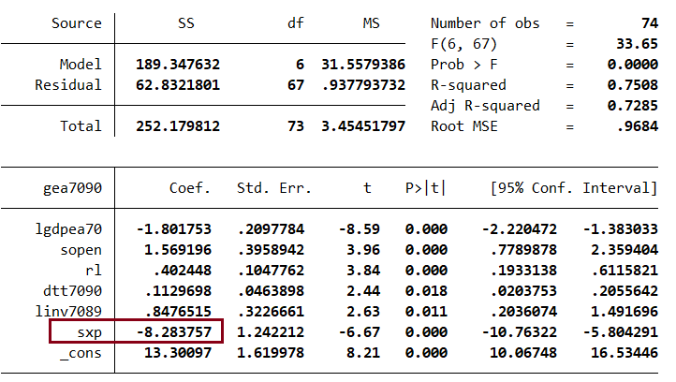

**Using “snr” as the measure of natural resource intensity**

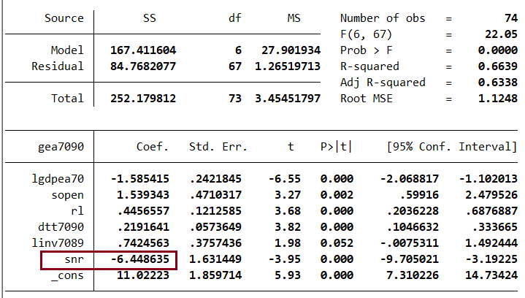

**Using “pxi70” as the measure of natural resource intensity**

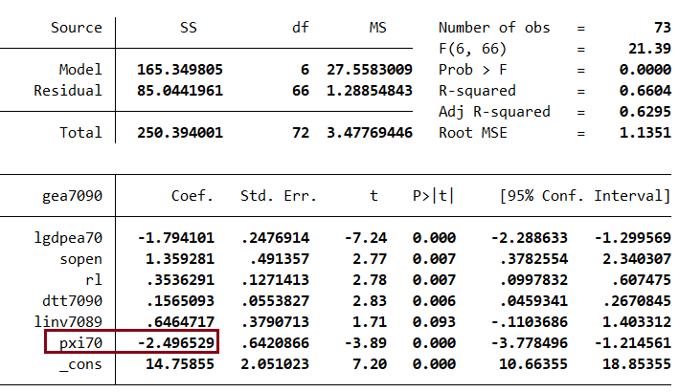

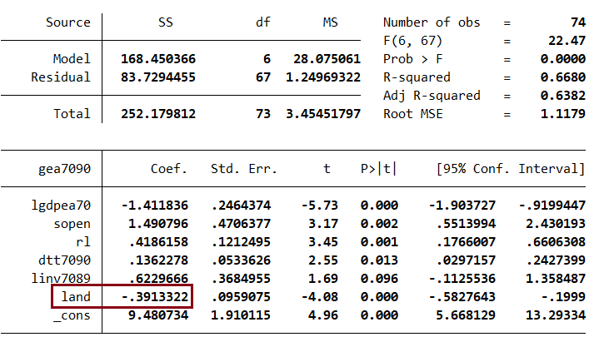**Using “land” as the measure of natural resource intensity**

The aim of using different measures is ensuring the robustness of the curse. The difference of 3.1 and 1.5 is the exclusion but the coefficient is still significant. The second regression of Table 3 uses the share of mineral production in GDP of 1971, which shows that 1971’s mineral production has a negative effect on the growth as well. The third tool of measurement is pxi70, share of primary exports to total exports in 1970. The coefficient of pxi70 is -2.5 which points the negative association between share of primary export in total and average annual growth of GDP. The final regression of Table 3 uses the land variable as measurement of natural resources. It is also negatively associated with the subsequent growth. With different variables and measurement methods, our model has passed the test of robustness which indicates the empirical truth of the theory of Natural Resource Curse. The reason behind the preference of sxp variable to the alternatives in the paper contains some issues of theoretical field and measurement. The size of the wealth which is claimed to be negatively affected by natural resource abundance can be captured better by the share of resource exports in whole GDP if we compare it with pxi70 or the share in just exports. As a matter of fact, PXI70’s coefficient was relatively small than others. Other mistake would be considering only the reserves of mineral and analyzing the natural resource effect based on this restricted variable. Basically, using SXP is more comprehensive than using SNR. The last replacement was “land-sxp” is also unnecessary since land area per person can not be a precise measure of primary production (depends on land productivity, land utilization, etc.). In conclusion, regression models of Table 3 have evidential value to the curse of natural resource abundance although using snr, pxi70 and land might not be necessary (nevertheless, they are still negatively related to economic growth).

**References**

Barsky, R., and L. Kilian. 2004. Oil and the macroeconomy since the 1970s. Journal of Economic Perspectives 18: 115–134.

Frankel, Jeffrey. 2010. "The Natural Resource Curse: A Survey," Working Paper Series rwp10-005, Harvard University, John F. Kennedy School of Government.

Sachs, Jeffrey & Warner, Andrew. (1996). Natural Resource Abundance and Economic Growth. 10.3386/w5398.